CURRICULUM VITAE

Name : Pankaj A Motreja

Date of Birth : 29th day of August 1982

Sex : Male

Father’s Name : Amarlal K Motreja

Address : 399, 2nd Main, 5th Cross,
Gokulam – III Stage,
Mysore – 570 002

Email id : thebulletboy@yahoo.com

Telephone : +91 0821 2510666

Lingual Capabilities : Read, write and speak English and Hindi. Speak Sindhi and Kannada

Educational Qualification:

Course | Institution | Board | Duration of the Course | Percentage  Obtained
C.B.S.E | St. Joseph’s Central School | A.I.S.S.E (CBSE) | 1988 - 1998 | 81 %
P.U.C | Mahajana Pre-University College | Karnataka P.U. Board | 1998 - 2000 | 67 %
B.E (Information Science) | Vidyavardhaka College of Engineering | Visveswaraiah Technological University | 2000 - Present | 73.15 %

Provided below are the marks secured in the past six semesters:

Semester | Percentage Obtained
I | 73.4 %
II | 63.0 %
III | 78.9 %
IV | 77.0 %
V | 71.3 %
VI | 75.3 %
Aggregate | 73.15 %
Computer Skill set:
Programming languages: C, C++, SQL, VB, HTML,Perl-CGI,Java.
Platforms: DOS, Windows, Unix, Linux
Assembly Level Programming : Intel 8086, Microchip PIC assembler

Projects Undertaken:

1. Hand Held Video Game : An embedded system (hand held gaming device) implemented using the PIC 16F84A microcontroller.

Programming Language : Microchip PIC Assembler
Skills Developed : Digital circuit design, Microchip PIC assembler

2. HashKey : A student record database implemented with Extendible Hashing which finds a hashed record with at most 2 read accesses.

Programming Language : C++
Skills Developed : OOP, File Structures design, Interface design.

- Car Rental Management : A front desk data entry software to manage the
booking of vehicles in a car rental agency considering booking date conflicts.

Programming Language : VB, SQL (Oracle 8i)
Skills Developed : Database design, Front-end interface design.

- EditX : GUI (text based) text editor written entirely in Intel 8086 assembler.

Programming Language : Intel 8086 Assembler.
Skills Developed : Assembly Level Programming, Interface design

- ASG (Another Stupid Game) : Car race simulation game. Included development
of a library of functions for handling text based graphics in C.

Programming Language : C / C++
Skills Developed : Collision Detection and Timing Algorithm design

- AC/DC : A DC power supply unit with user settable output voltage (in the range
of 0-24V) and three regulated preset voltages (5V, 9V, 12V).

Skills Developed : Circuit design, soldering

- Parallel Port Tester : A hard-wired circuit and software (written in C) to test the
Data, Status and Control ports of a Standard Parallel Port.

Programming Language : C
Skills Developed : Circuit design, Port I/O at hardware and software levels
- Dungeons and Dragons : An interactive game which employs the Multi-Thread
and Graphics features of Java

Programming Language : Java
Skills Developed : Java graphics & multi-thread programming.

- Audio Streaming : A Client-Server system to provide for the streaming of MP3
Audio files over a network, using UDP for transfer of data. The project involved
developing an application layer protocol for control information (over TCP).

Programming Language : C (Linux)
Skills Developed : Protocol design and development, Linux system calls.

- Web Forum Service : A website which allows users to post queries and replies.

Programming Language : Perl-CGI
Skills Developed : Internet programming, Website design.

Extracurricular Activities:

- Main organizer for the annual college cultural fest, VIDYUTH for the year 2003

- Member of the Organization Committee and Poster design committee, for the
college’s annual cultural fest, VIDYUTH, for the years 2001 and 2003.

- Represented the college in the state-level VTU Fest for the academic year 2002-
2003

- Member of the Cultural Committee of Vidyavardhaka College of Engineering
for the period 2001-2003.

- Participated in competitions and won many prizes in various college fests
held in Mysore for competitions like Dumb Charades, Skit, Mad Ads, Movie
Spoof, Western Music Competition etc.

- Member of ACCESS (Computer Science & Information Science Department
committee) for the academic year 2001-2002

- Co-Founder of Next Step, a self help group aimed at improving leadership and
communication skills with an impetus on job placement.

- Co-Founder and editor of ‘The Communique’, class newsletter during the period
1996-1997

- Member of the college Rock band (Rhythm and Bass Guitar)
Other Achievements:

- Attended FEEL – Human Resource Development Program conducted by ‘Center
for Leadership and Human Resource Development (CLHRD) ’, Mangalore.

- Design & Editing of a short audio/video clip which was screened as part of the
World Environment Day Celebrations 2002 in college.

- Received a certificate for academic excellence from St. Joseph’s Central School
for the year 1994-1995

- Acquired a distinction in the ‘C/C++ Programming’ course at Yashas Softech,
Mysore in the year 2000

Hobbies:
Biking, music (Guitar), reading, theatre, photo editing, numismatics, philately.

SCREENSHOTS / PICTURES

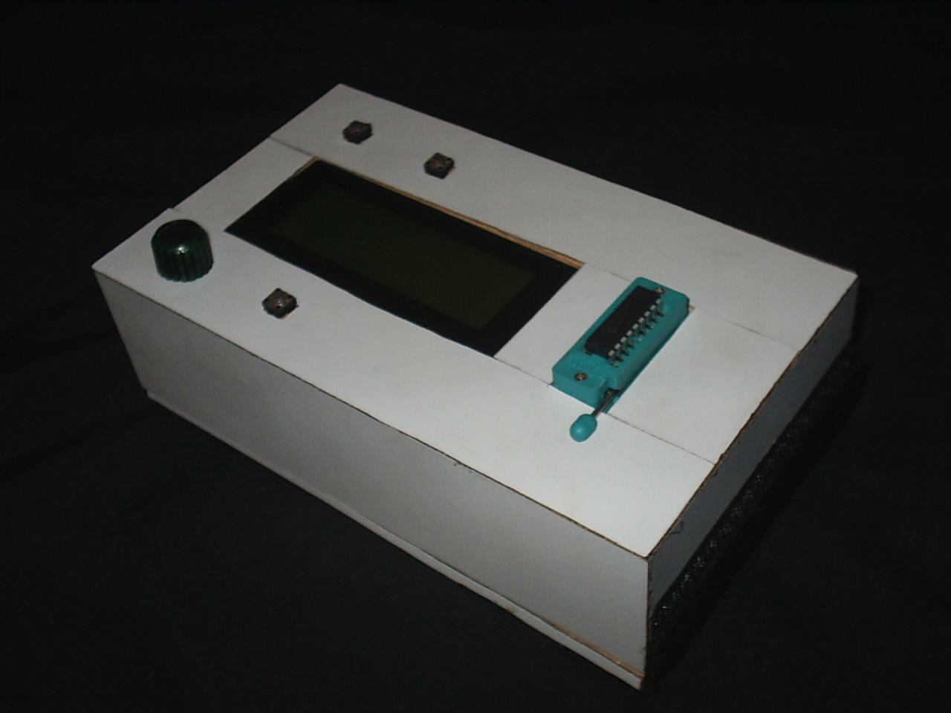

Hand Held Video Game : The photograph shows the completed system.
The PIC 16F84A microcontroller and LCD screen are in clear view.

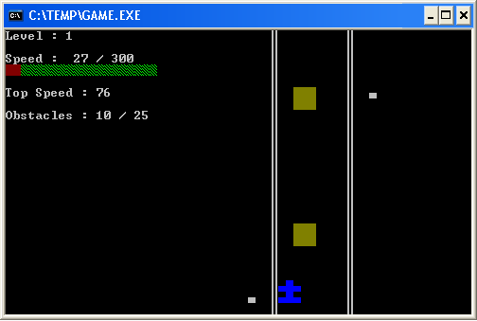

Another Stupid Game : The screenshot shows the obstacles and the car
in action.

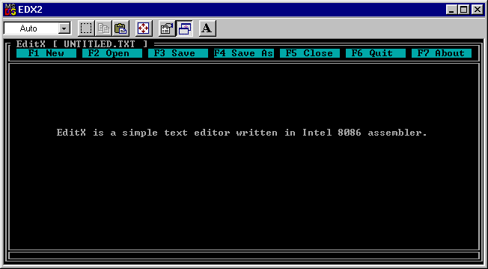

EditX : The screenshot shows the editing interface with the menu options.

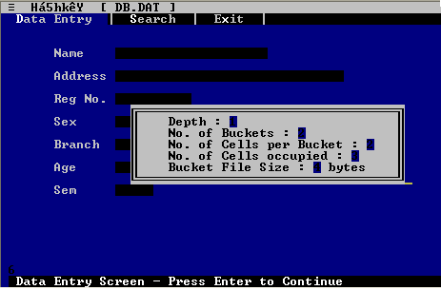

HashKey : Data Entry Screen for the student record database with the
Information dialog box displayed.
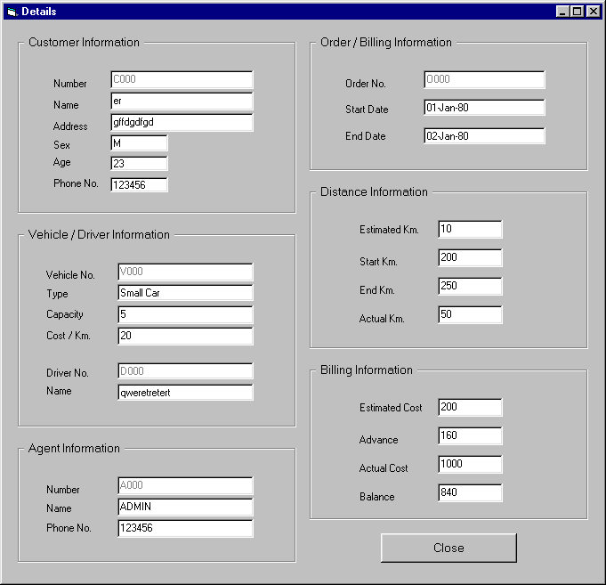

Car Rental Agency Details Form : This form shows details of all entities
in the system.

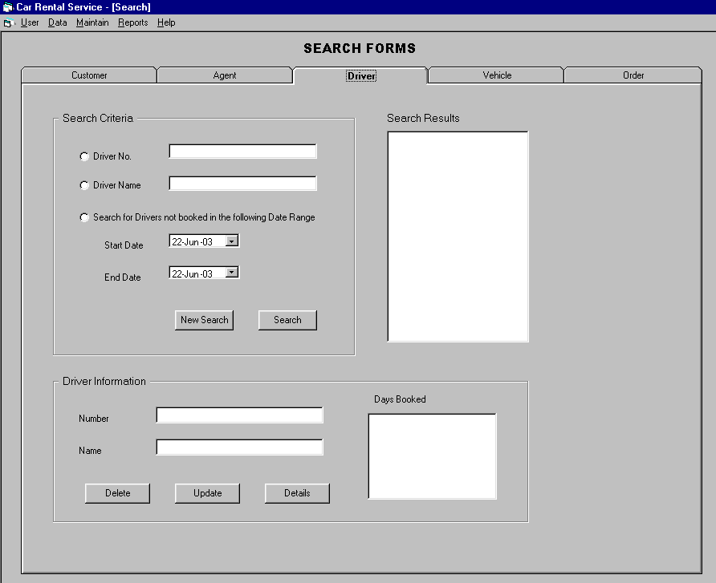

Car Rental Agency Search Form : Searches can be conducted on the basis
of each entity and also on the basis of additional criteria like days booked, etc.

